**Name: Bulbul Singh**

**Reg. no: 19BEC1243**

**Date: 23-11-2021**

**EXPERIMENT NO: 12**

**Design and Troubleshooting of Solar Power Inverter circuit**

**Aim:** To design a solar Power inverter circuit using LTSpice tool.

**Software used:** LTSpice

**Components required:**

* Solar Panel : 12V 20watts (1600mA)
* LM317: Three terminal Positive voltage regulator (Output voltage from 1.25V to 37V with more than 1.5A current)
* 3A, 50V Shottky diode
* 12/4.5Ah SLA Battery (dc bias to inverter circuit)
* CD4047 PWM generator / ASTABLE multivibrator
* Produces switching waveform
* Inverter circuit using IC CD4047 (Switching Pulse Oscillator): Monostable / Astable multivibrator IC CD4047
* IC: 14 pin Dual in line package
* MOSFET Drivers IRF540N (Power mosfet) Fast switching
* Transformer X1: Reverse with specifications as 230V primary 9V-0-9V /1.5A secondary winding center tapped transformer
* Metal oxide Varistor protects electronic device connected at output.

**Task 1:** Plot the regulated voltage across Vregulated

**Circuit:**

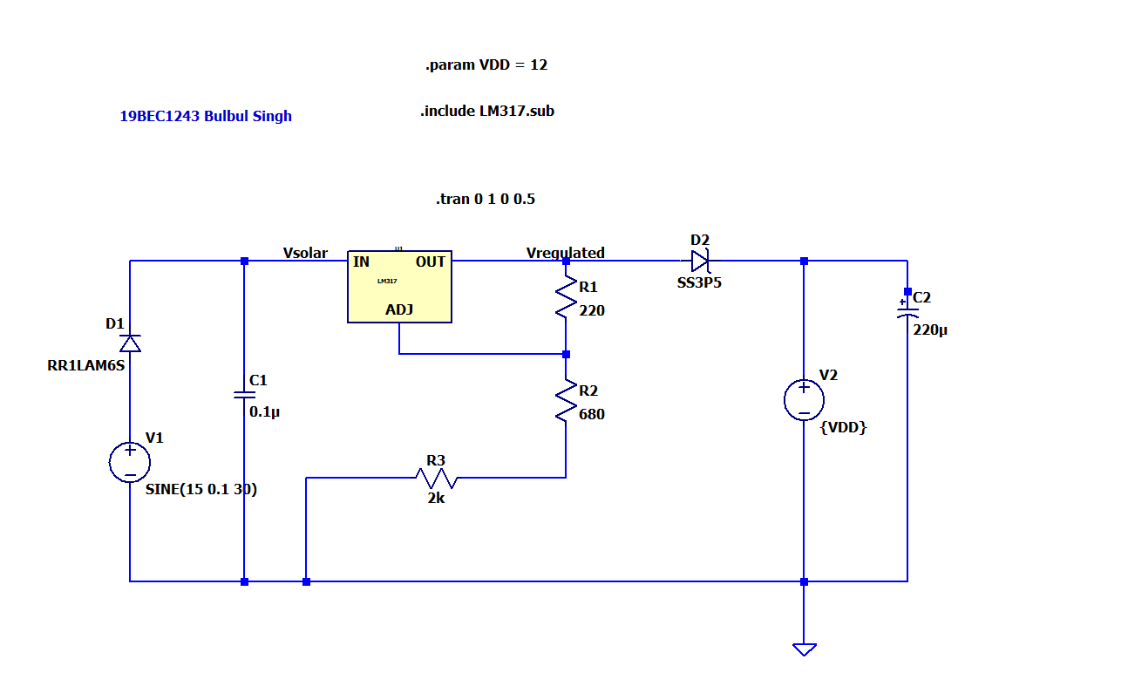

**Output:**

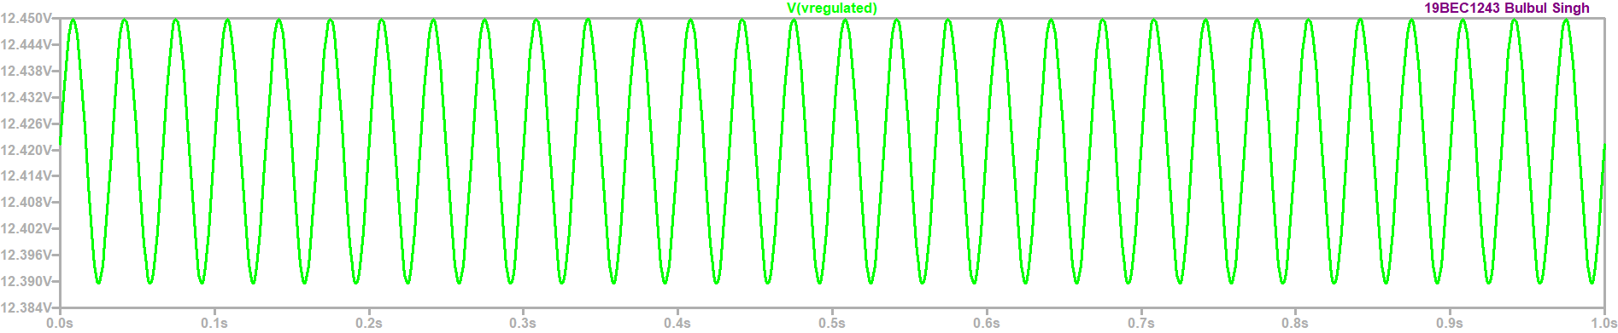

**Result:** Thus we have plotted voltage Vregulated.

**Task 2:** IC supply and LED check

**Circuit:**

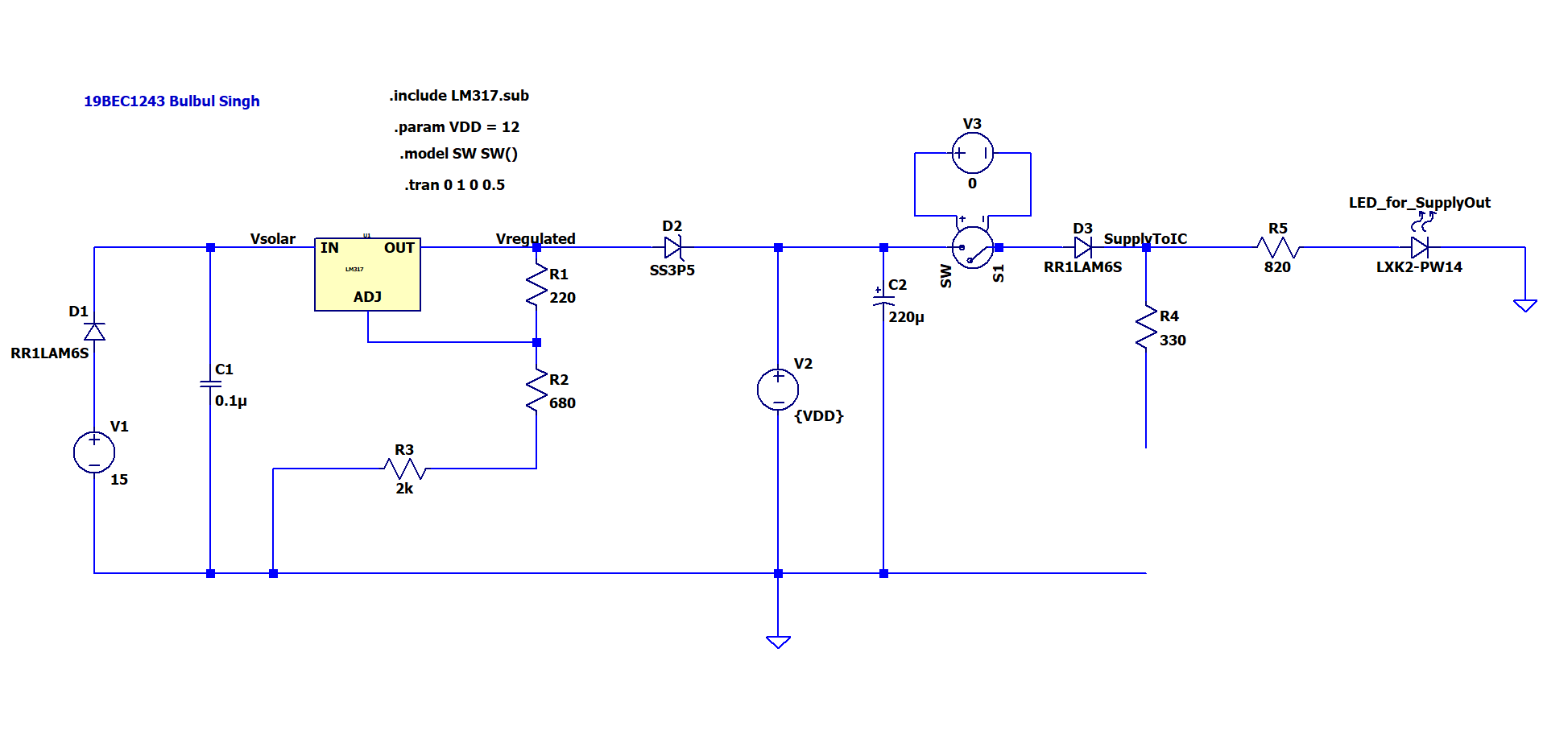

**Output:**

When switch is OFF:

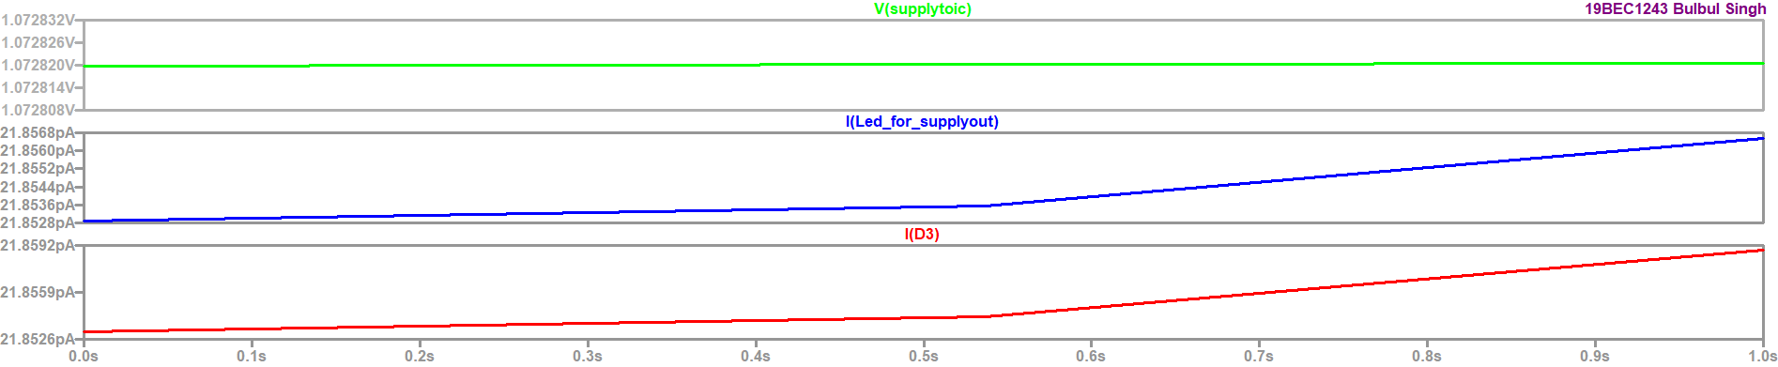

When switch is ON:

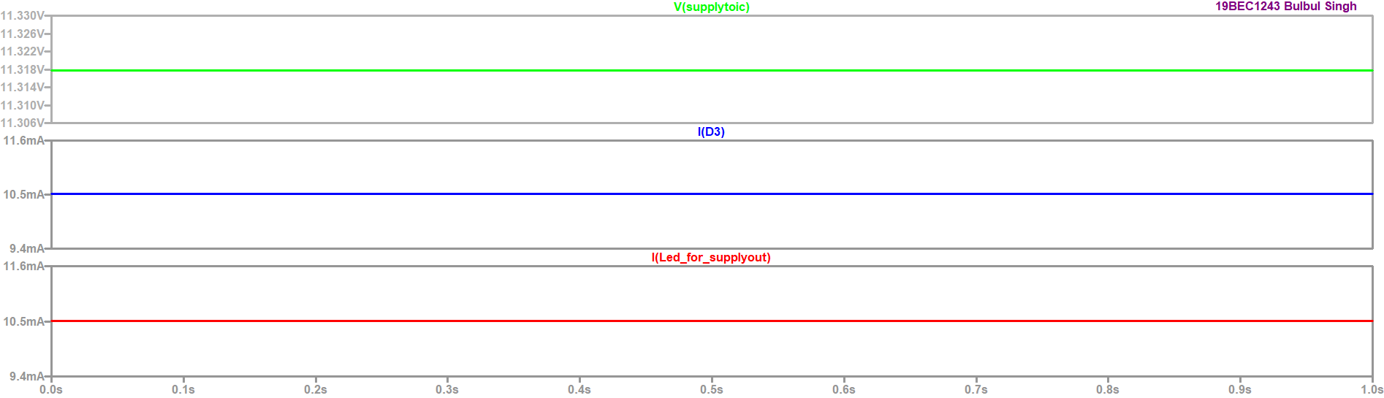

**Result:** Thus we plotted Vsupply to IC and current through diode when switch is ON and OFF.

**Task 3:** Plot the waveform at VQ and VQbar.

**Circuit:**

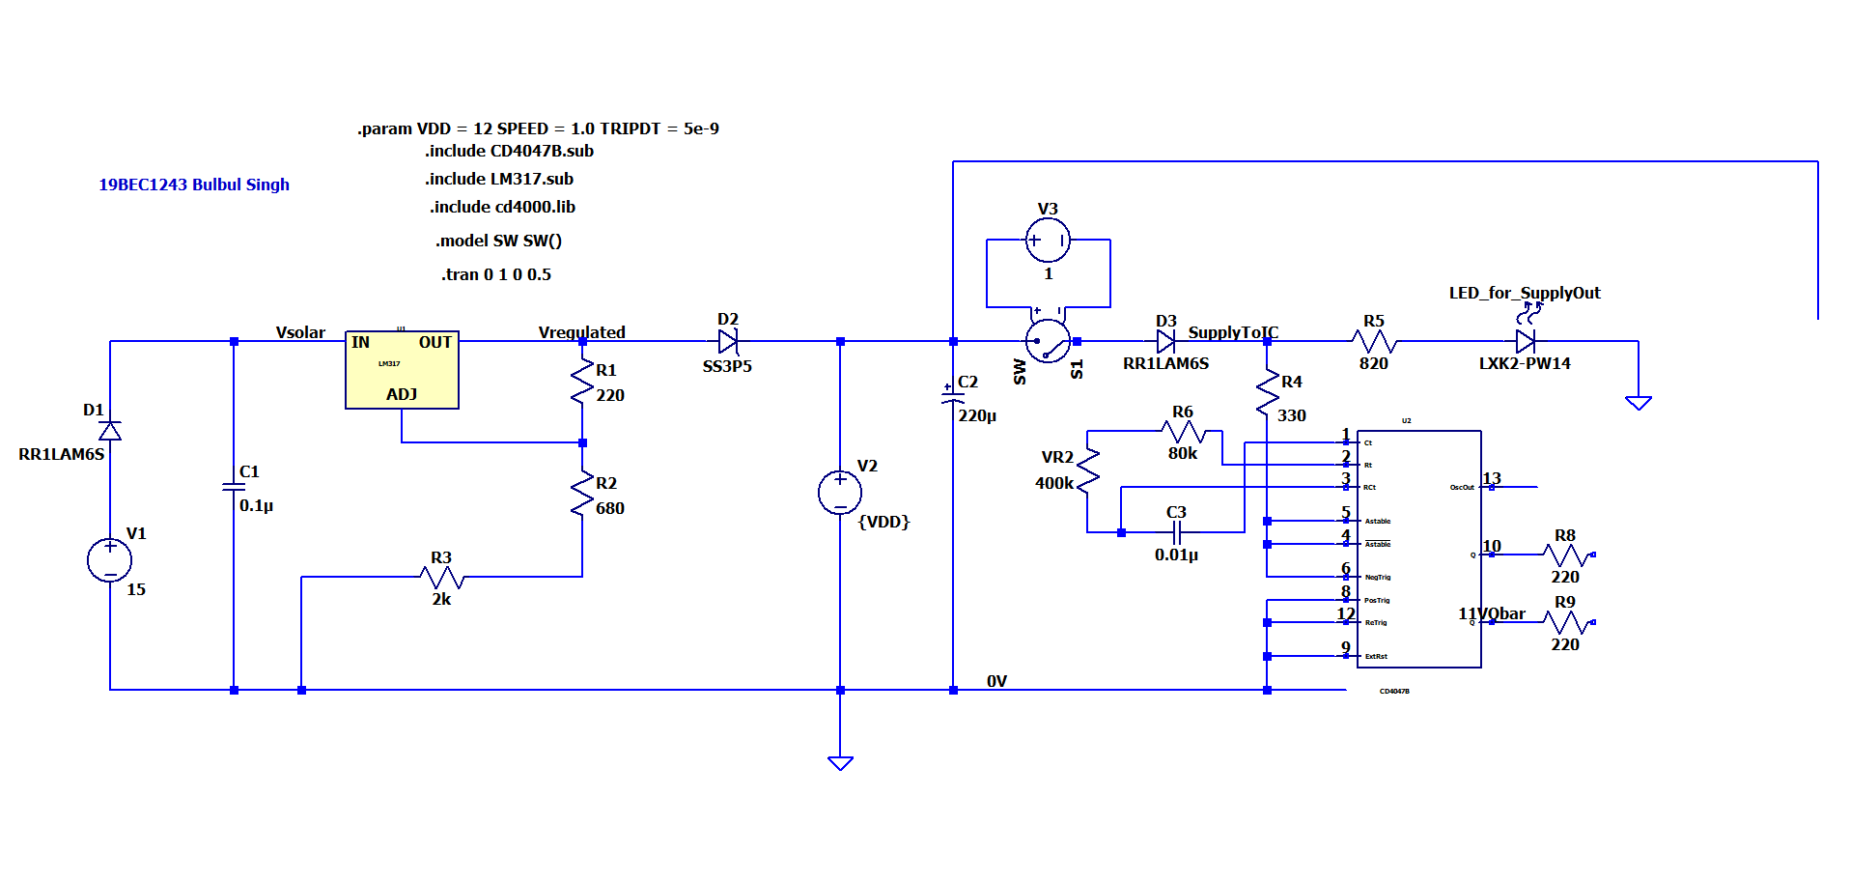

**Output:**

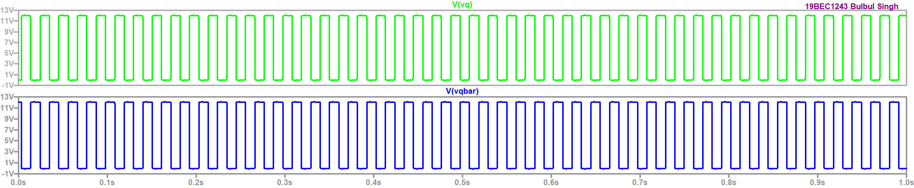

**Result:** Thus we plotted VQ and VQbar.

**Task 4:** Plot Vp1, Vp2, Vp1-Vp2, Vout.

**Circuit:**

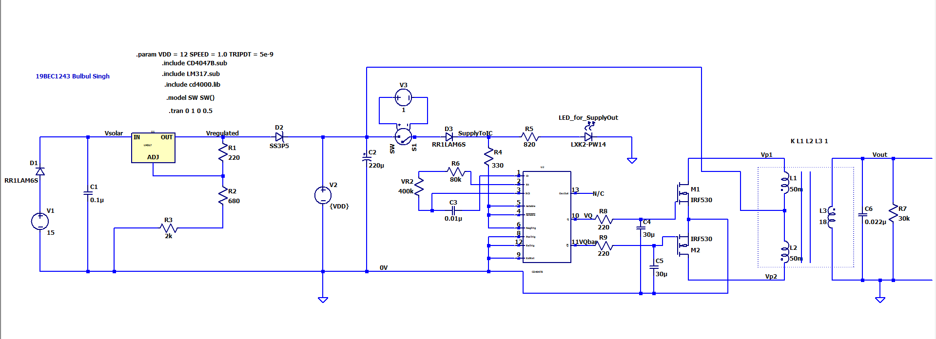

**Output:**

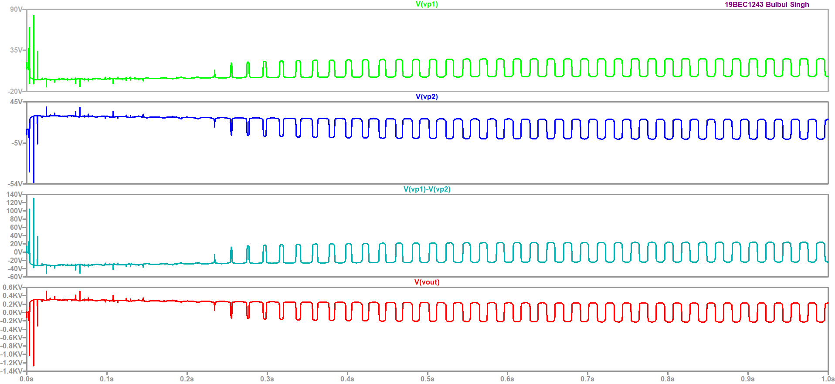

**Result:** Thus we plotted Vp1, Vp2, Vp1-Vp2 and Vout.